* **Project Overview:**

**Domain: Online Blood Bank Management System**

Online blood bank management system provides useful and organized information to users who are searching for blood. Also it provides a smart system for donors who are interested to donate blood. Donors are met with a registration process which allows them to process their information into a database and also given a login credential. The login credential allows the donors to enter into their own dashboard which includes the option to view, update and delete their information. Besides they can see the blood requests which have been posted by people searching for blood. The users who are searching for blood don’t need to go through login or registration process. They can enter the database and search for blood by group, location or by both.

* **Project Objectives:**

1. To assist in the management of blood donor records and ease or control the distribution of blood based on the user’s demand.
2. To reduce the complexity of the system to find blood donors in emergency.
3. To provide a simple and quick interaction among the donors and seekers.
4. To keep record of the donors, patient who seek blood and available blood for different groups.

* **Requirements Analysis:**

1. **Donor registration:**

Donors has to provide their personal information (i.e., Name, Age, Gender, Weight, Blood Group, Division, Area, Email, Mobile No.), Medical Information (i.e., smoking, blood pressure and status of other diseases), Login Credential, Donation History which will include the date and the hospital name of the last donation of the donor.

1. **Donor login:**

Donors can log in and enter their dashboard which will enable them to view, update and delete their information.

1. **Searching for donors by blood group, by area**

Users can search donor who have been registered by the donors’ blood group or area or by both.

1. **Users requesting for blood**

Users can request for blood by providing their information (i.e., Name, Age, Gender, Weight, Blood Group, Disease, Division, Area, Email, Mobile No.) in a form which will be displayed for public.

1. **Available donors displaying**

All the donors who have registered and their detailed information will be displayed here. Their status of donation, meaning if they can or cannot donate blood will also be displayed here.

These requirements are met by PHP, HTML and CSS. PHP, the tool of backend, has been used to insert, update, retrieve or delete data from database. The front-end, the designing which is the user interface has been made by HTML and CSS.

Software used to create and run the system:

1. XAMPP Control Panel v3.2.4.

2. Google Chrome.

3. Visual Studio Code.

* **Design:**

**Entity Relationship Model:**

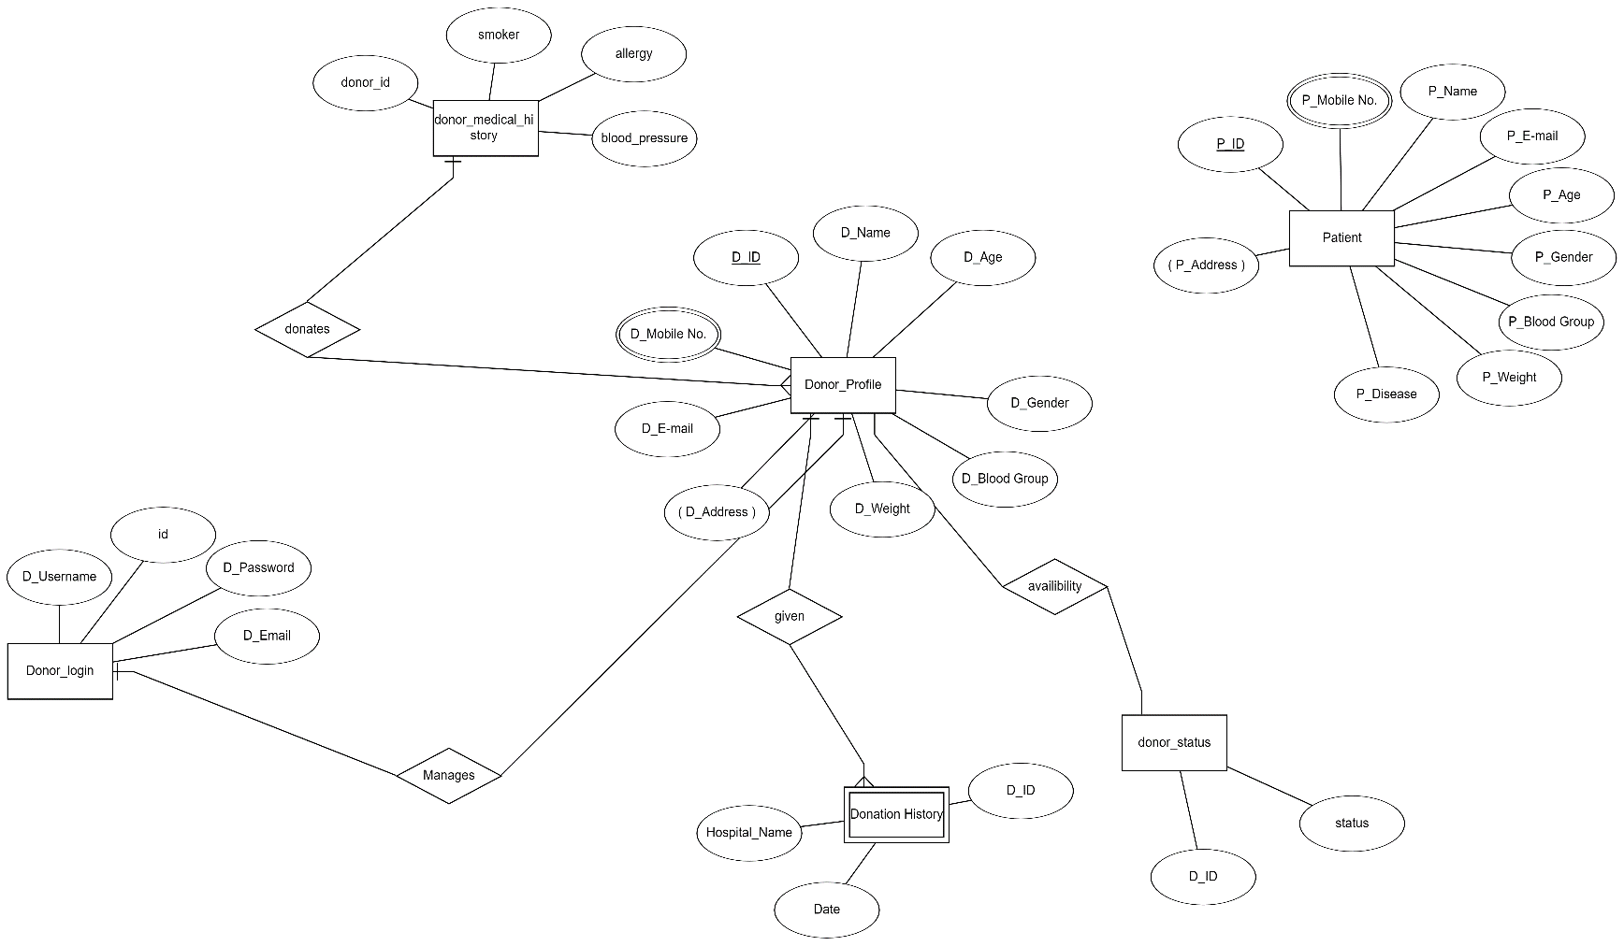

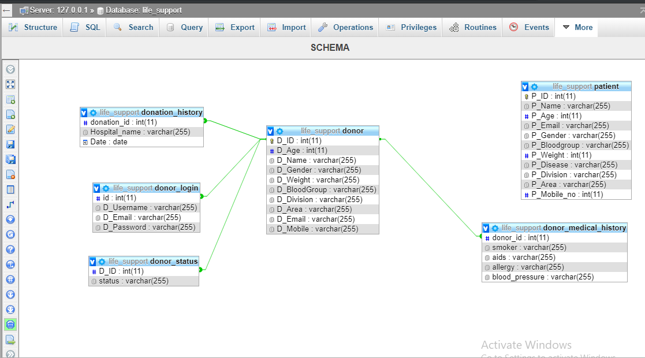**Schema Diagram:**

* **Implementation and Results:**

The project is divided into some parts such as, donor registration, login, donor information, update, delete, search information of donor by blood group or location or by both. Login system is validated by proper codes so that incorrect username or password can not be processed.

In the donor registration part, the information was processed into database by:

* "INSERT INTO donor(D_Age, D_Name, D_Gender, D_Weight, D_BloodGroup, D_Division, D_Area, D_Email, D_Mobile)
* VALUES('$age', '$name', '$gender', '$weight', '$bloodgroup', '$division', '$area', '$email', '$mobile')";
* "INSERT INTO donor_login(id, D_Username, D_Email, D_Password)
* VALUES('$id2','$username', '$email', '$password')";
* "INSERT INTO donor_medical_history(donor_id, smoker, aids, allergy, blood_pressure)
* VALUES('$id2', '$smoker', '$aids', '$allergy', '$bloodpressure')";
* $sql = "INSERT INTO donation_history(donation_id, Hospital_name, Date)
* VALUES('$id2', '$hospital', '$lastdon')";

Here, in the donor status part, we took the info from donor of his last donation then the date is subtracted by current date which gives the verdict of whether he can or can not donate blood. If his age is less than 18 years or he has donated blood in less than 120 days, then he is not able to donate blood. Here’s the query:

$sql = "SELECT Date from donation_history where donation_id='$id2'";

$result = mysqli_query($conn, $sql);

$row1 = mysqli_fetch_assoc($result);

$name = $row1['Date'];

$now = time(); // or your date as well

$your_date = strtotime("$name");

$datediff = $now - $your_date;

$duration = round($datediff / (60 * 60 * 24));

if (($duration > 120) && ($age > 18)) {

$sql = "INSERT INTO donor_status(D_ID, status)

VALUES('$id2', 'Can Donate')";

$conn->query($sql);

} else {

$left = 120 - $duration;

$sql = "INSERT INTO donor_status(D_ID, status)

VALUES('$id2', '$left days left to donate')";

$conn->query($sql);

To request for blood, patient has to fill up a form as well. The queries are similar to before.

Login credentials are matched with database by,

"SELECT * FROM donor_login WHERE D_Username='$username' AND D_Password='$password'"

To search for blood by blood group:

To search for blood by blood group and location:

"SELECT * FROM `donor` WHERE D_BloodGroup='$bloodgroup'"

"SELECT * FROM `donor` WHERE D_BloodGroup='$bloodgroup' AND D_Division='$division' AND D_Area='$area'"

Here are the update queries:

$sql = "UPDATE donor SET D_Name ='$name', D_Age ='$age', D_Email ='$email', D_Weight ='$weight', D_BloodGroup ='$bloodgroup',D_Mobile='$mobile', D_Division ='$division', D_Area ='$area', D_Gender ='$gender' WHERE D_ID='$id'";

    $sql1 = "UPDATE donor_login SET D_Username ='$username', D_Password ='$password_1', D_Email ='$email' WHERE id='$id'";

    $sql2 = "UPDATE donation_history SET Hospital_name ='$hospital', Date ='$lastdon' WHERE donation_id='$id'";

    $sql3 = "UPDATE donor_medical_history SET smoker ='$smoker', aids ='$aids', allergy ='$allergy', blood_pressure ='$bloodpressure' WHERE donor_id='$id'";

To view detail of each donor by their id:

$sql = "SELECT * from donor,donation_history,donor_medical_history,donor_status where donor.D_ID='$id' AND donation_id='$id' AND donor_id='$id' AND donor_status.D_ID='$id'";

To view detail of all donor:

"SELECT * FROM donor"

To delete one’s donor information:

$sql = "DELETE FROM donor WHERE D_ID = '$id'";

**Here are the screenshots of the project:**

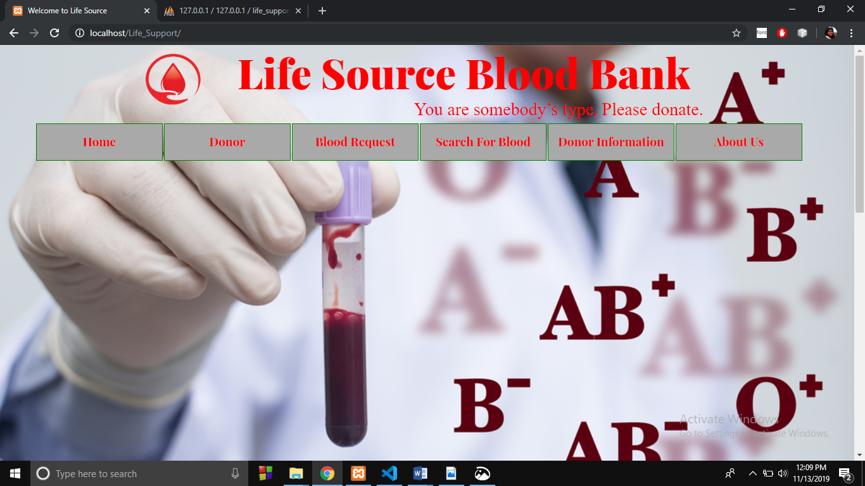

Fig 1: Front Page_1

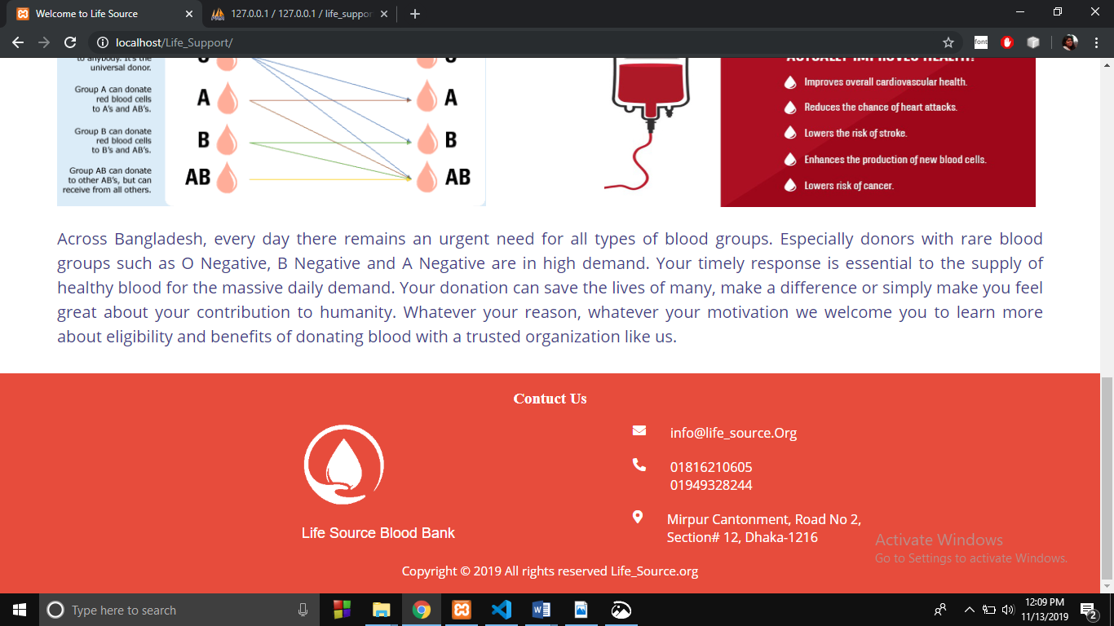

Fig. 2: Front Page_2

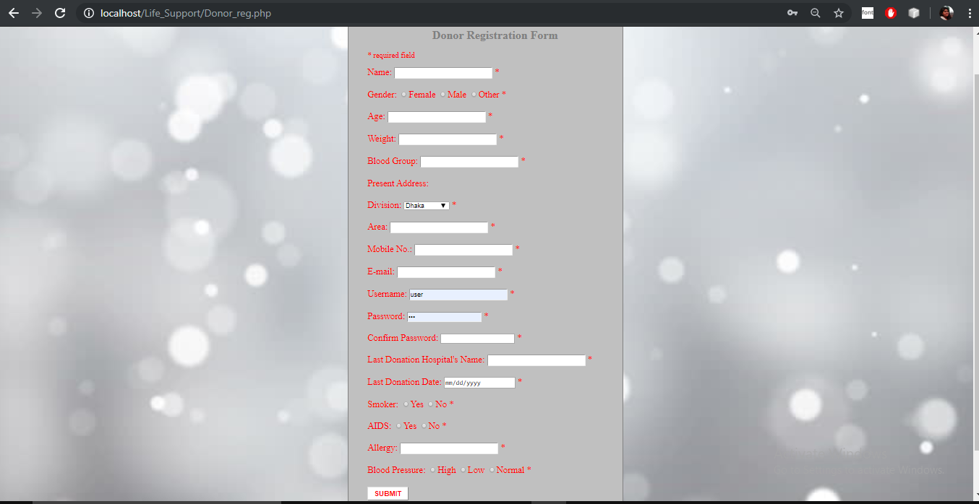

Fig. 3: Donor Registration Form

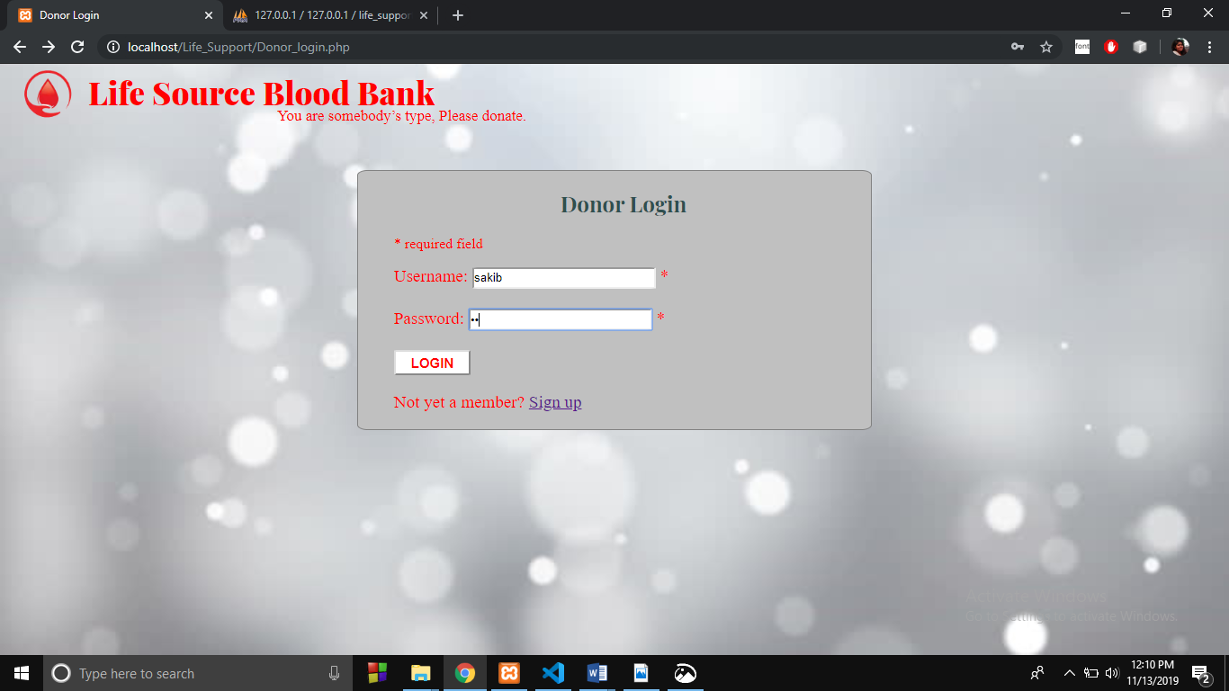

Fig. 4: Donor Login Page

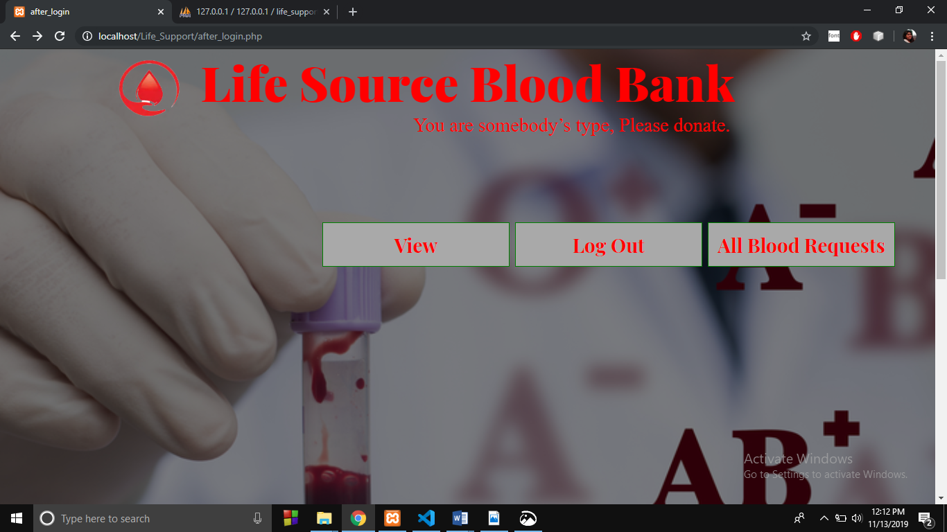

Fig. 5: Donor Dashboard (After Login)

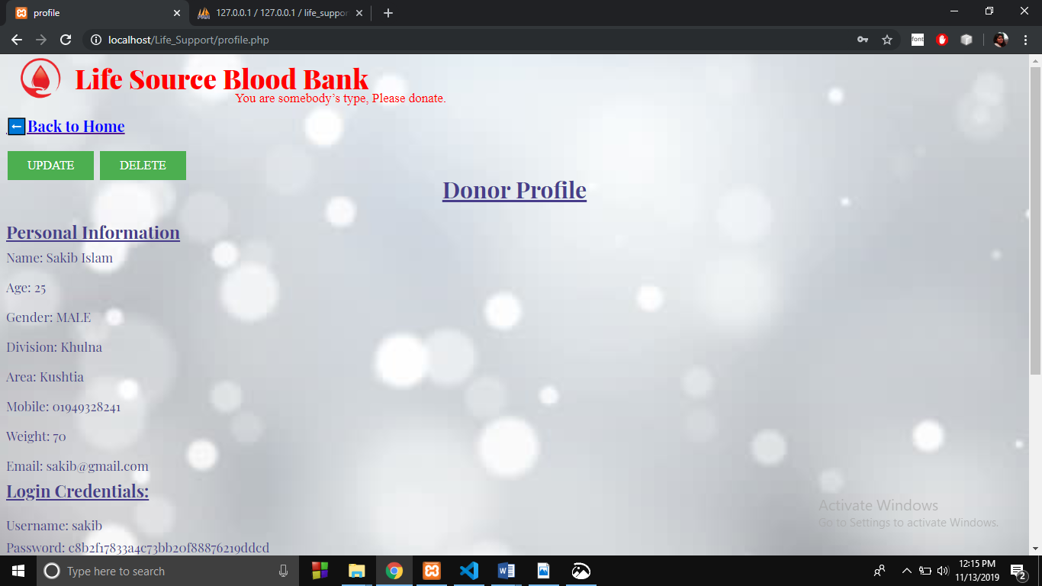

Fig. 6: Donor Profile Page

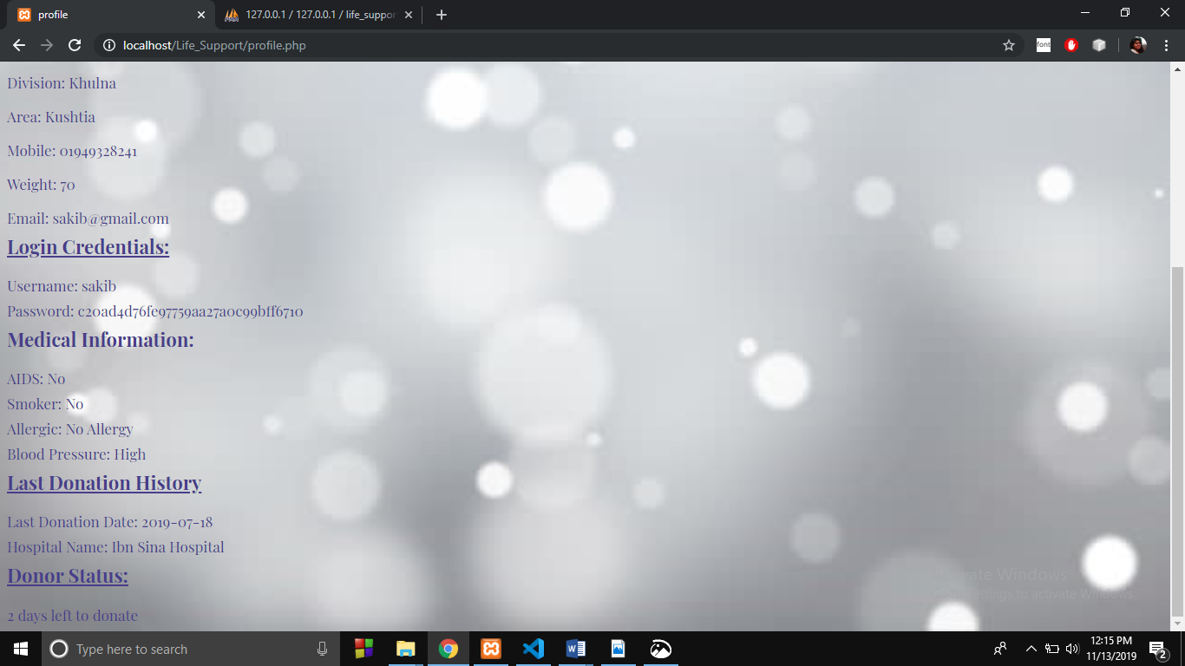

Fig. 7: Donor Profile Page Part 2

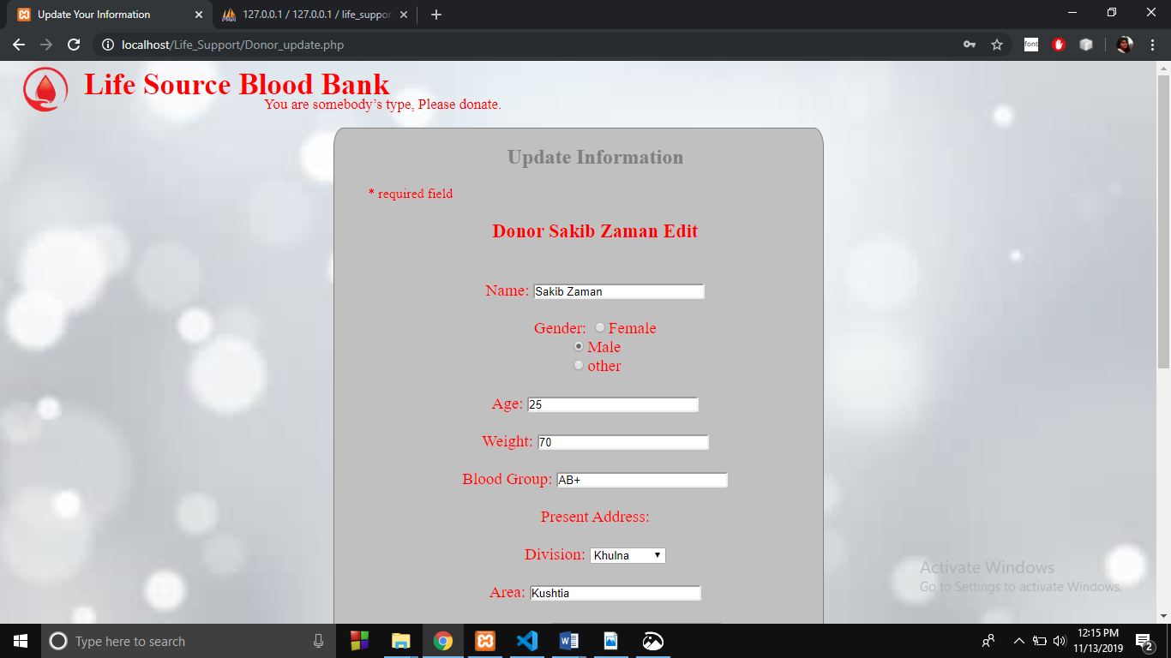

Fig. 8: Update Information Page

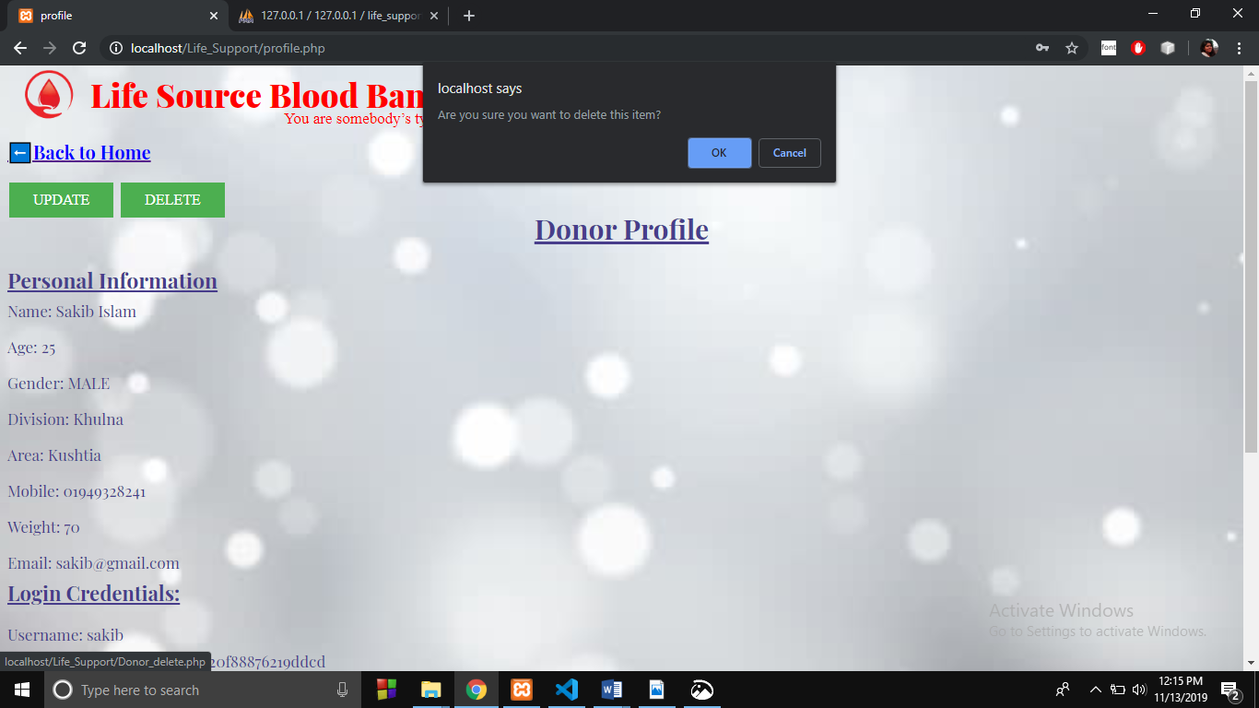

Fig. 9: Delete Option

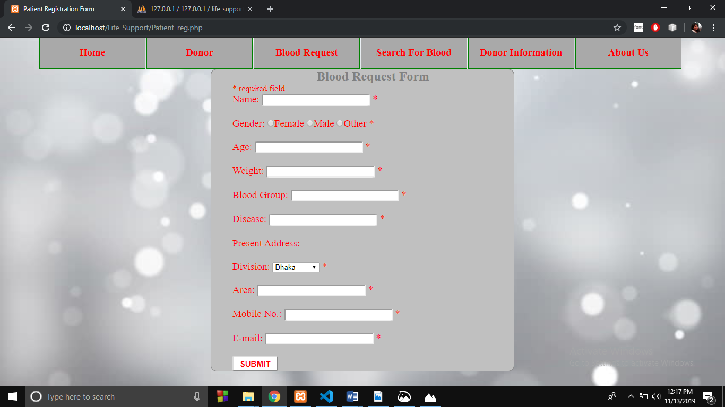

Fig. 10: Blood Request Form

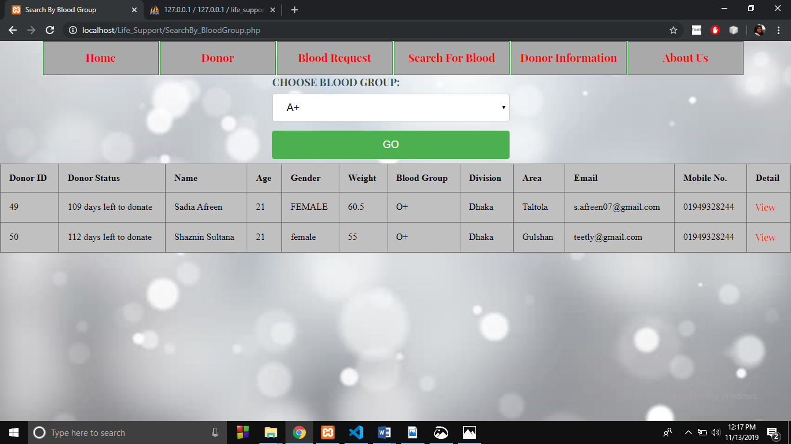

Fig. 11: Search by Blood Group

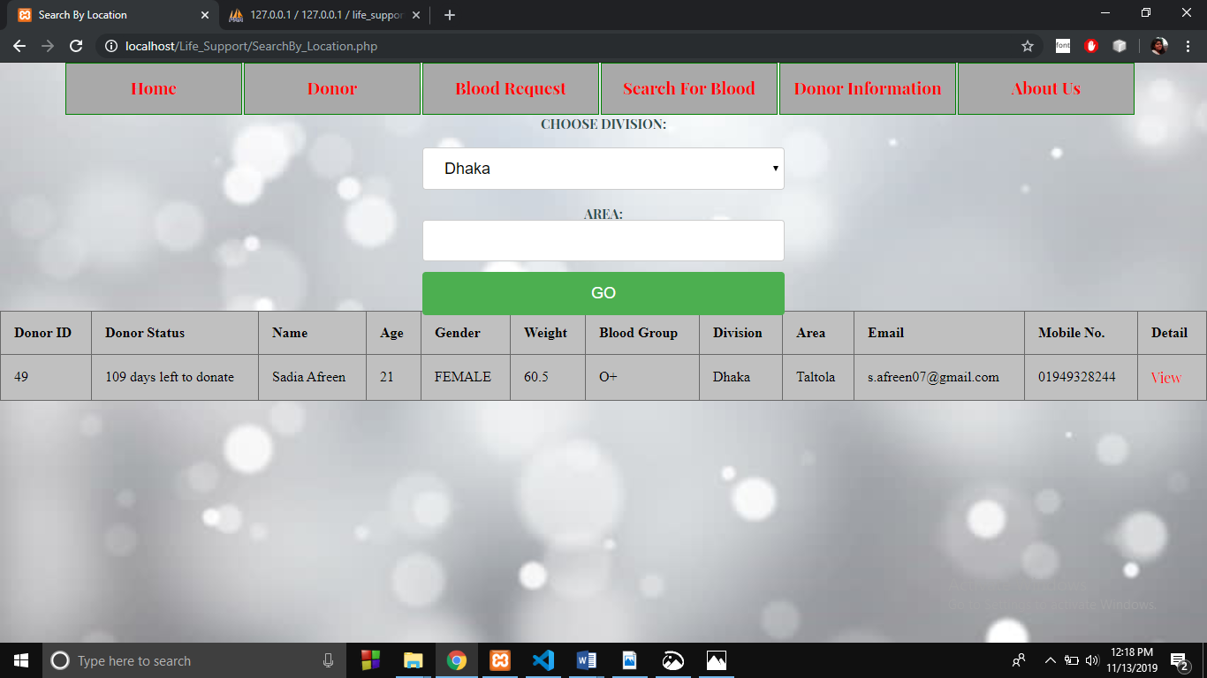

Fig. 12: Search by Location

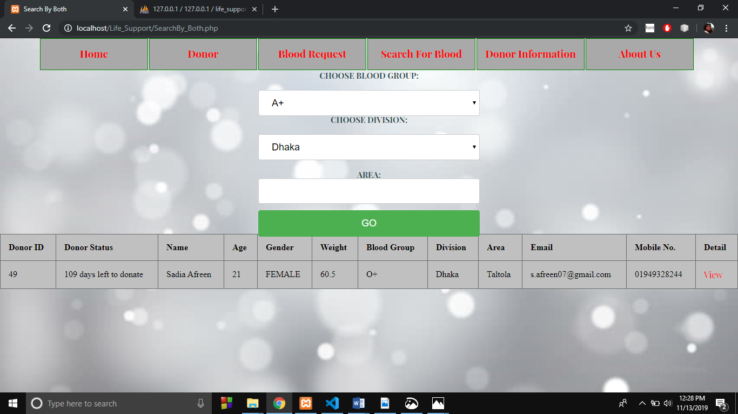

Fig. 13: Search by Both

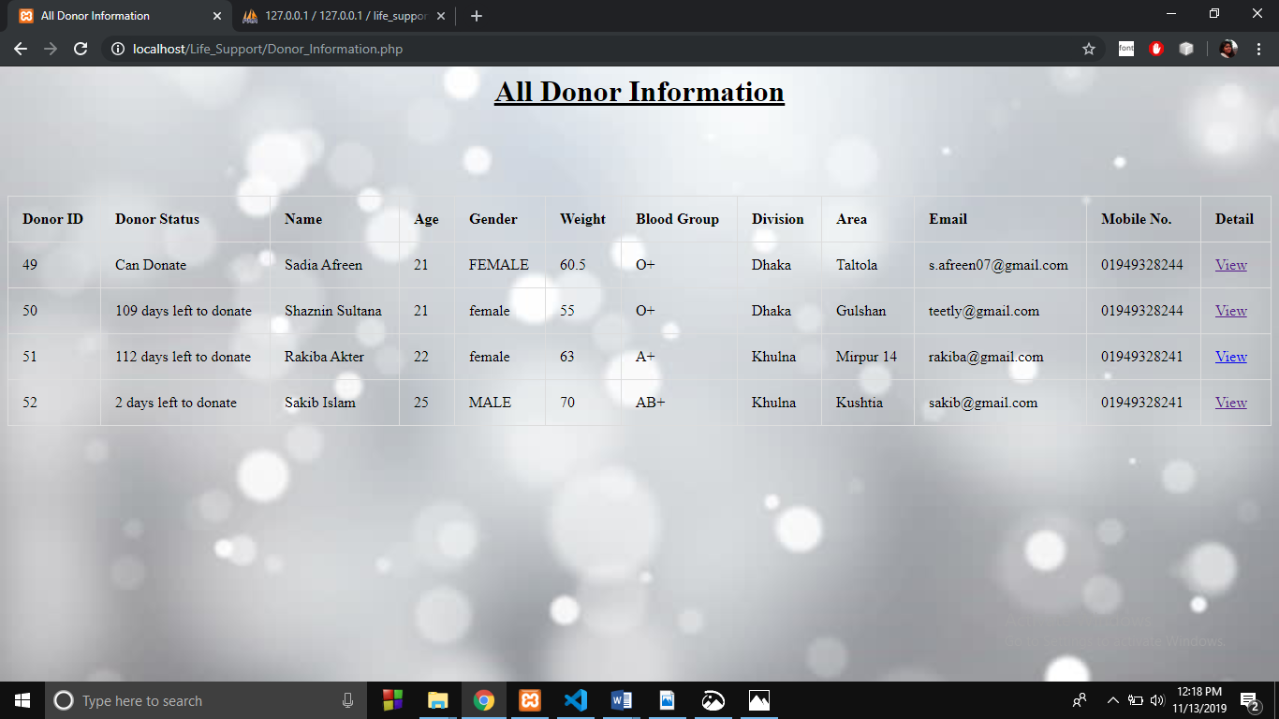

Fig. 14: All Donor Information

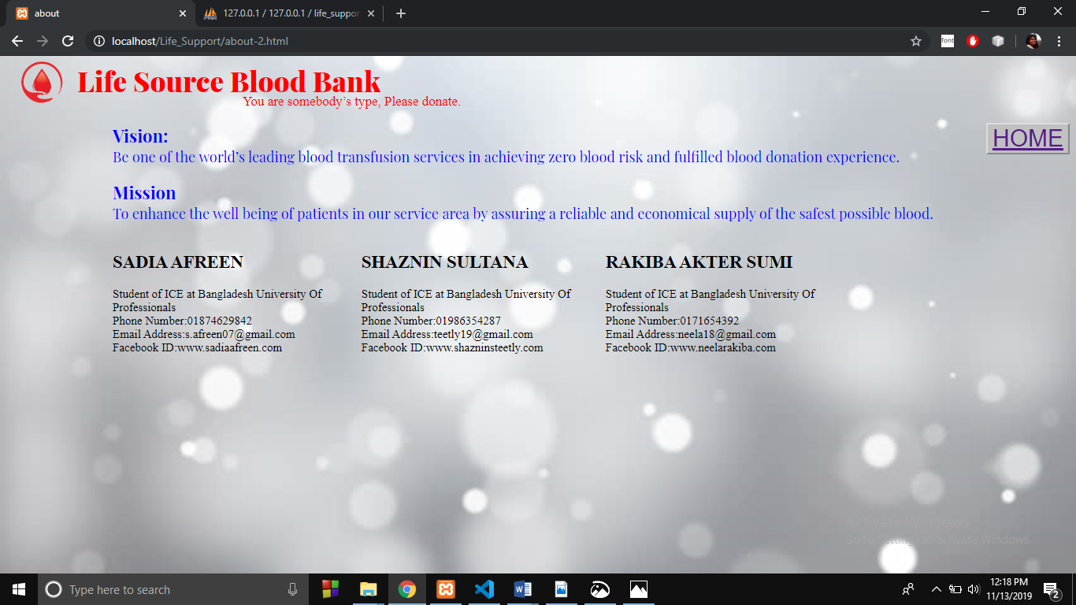

Fig. 15: About Us

* **Conclusion:**

The project introduces an online based blood bank system which key features include the registration and sign in system of a donor, update-delete information, the status of a donor meaning if he is able or not able to give blood and if he is not then how many days left for him to be able to donate blood again. Also various search queries, donor information, request for blood are some of the key features. The project was made by following the ER, SCHEMA diagrams thoroughly. The project has a few limitations such as, donors cannot add their pictures. It can be improved by solving the limitations. Also, an android or an IOS based app of the project and financial statement of the donations can be done.

Although there are some drawbacks, we tried to create a system where both donors and patients searching for blood can get benefitted.

* **References:**

[1] http://www.iata.org/publications/Pages/code-search.aspx

[2] https://www.w3schools.com/html

[3] https://www.w3schools.com/php/

[4]https://www.youtube.com/playlist?list=PLgGbWId6zgaWZkPFI4Sc9QXDmmOWa1v5F